VISVESVARAYA TECHNOLOGICAL UNIVERSITY

Jnana Sangama, Belagavi - 590018



Mini Project Report

on

“DRIVER DROWSINESS DETECTION”

Submitted in partial fulfillment of the requirements for the award of the degree of

BACHELOR OF ENGINEERING

in

ARTIFICIAL INTELLIGENCE AND MACHINE LEARNING ENGINEERING

By

|  |  |
| --- | --- |
| SANJAY S M | 4MT20AI038 |
| ANKITH SHETTY | 4MT20AI004 |
| NEHA B S | 4MT20AI021 |
|  |  |

Under the Guidance of

Mrs. Radha EG

Associate Professor



DEPARTMENT OF ARTIFICIAL INTELLIGENCE AND MACHINE LEARNING ENGINEERING

MANGALORE INSTITUTE OF TECHNOLOGY & ENGINEERING

*Accredited by NAAC with A+ Grade, An ISO 9001: 2015 Certified Institution*

(*A Unit of Rajalaxmi Education Trust®, Mangalore - 575001*)

Affiliated to VTU, Belagavi, Approved by AICTE, New Delhi

Badaga Mijar, Moodabidri-574225, Karnataka

2022-23

MANGALORE INSTITUTE OF TECHNOLOGY & ENGINEERING

*Accredited by NAAC with A+ Grade, An ISO 9001: 2015 Certified Institution*

(*A Unit of Rajalaxmi Education Trust®, Mangalore - 575001*)

Affiliated to VTU, Belagavi, Approved by AICTE, New Delhi

Badaga Mijar, Moodabidri-574225, Karnataka

**Department of Artificial Intelligence and Machine Learning**

**CERTIFICATE**

This is to certify that the mini project entitled “DRIVER DROWSINESS DETECTION” is a bonafide work carried out by Mr. **SANJAY S M(4MT20AI038)**, Mr. **ANKITH SHETTY(4MT20AI004)**, & Ms. **NEHA B S (4MT20AI021)** in partial fulfillment for the requirement of 5th semester DBMS Laboratory with mini project (18CSL58). It is certified that all the corrections/suggestions indicated for the Internal Assessment have been incorporated in the report. The mini project has been approved as it satisfies the academic requirement in respect of the 18CSL58 prescribed for the 5th Semester B.E in Computer Science & Engineering Program by the **Visvesvaraya Technological University, Belagavi**, for the academic year 2022 – 2023.

|  |
| --- |
| ………………………….. ………………………….. |
| Signature of the Guide Signature of the HOD  **Mrs. Radha EG Mr. Sunil Kumar S** |

|  |  |
| --- | --- |
| **Name of the Examiners** | **Signature with Date** |
| 1. **………………………** | **………………………** |
| 1. **………………………** | **………………………** |

**ACKNOWLEDGEMENT**

The successful completion of any significant task is the outcome of invaluable aggregate combination of different people in radial direction explicitly and implicitly. We would therefore take opportunity to thank and express our gratitude to all those without whom the completion of project would not be possible.

We express our thanks to **Mr. Sunil Kumar S,** **Associate Professor, Head of the Department of Artificial Intelligence and Machine Learning Engineering** for having provided all the facilities that helped us in timely completion of this report.

We express our sincere gratitude to **Mrs. Radha EG,** **Associate Professor, Head of the Department of Artificial Intelligence and Machine Learning Engineering** for his support and guidance.

We would like to thank **Dr. Prashanth CM**, **Principal, Mangalore Institute of Technology and Engineering, Moodabidri** for his support and encouragement.

I express my sincere gratitude to our institution and management for providing us with good infrastructure, laboratory facilities, qualified and inspiring staffs, and whose guidance was of immense help in completion of this seminar successfully.

|  |
| --- |
| **SANJAY S M** |
| **4MT20AI038** |
|  |
| **ANKITH SHETTY** |
| **4MT20AI004** |
|  |
| **NEHA B S** |
| **4MT20AI021** |

ABSTRACT

Driver drowsiness is a significant contributing factor to road accidents, necessitating the development of robust drowsiness detection systems. This project proposes an image processing-based approach for driver drowsiness detection using fuzzy logic. The code utilizes advanced image processing techniques to analyze facial features, including eyes, nose, and mouth, enabling the assessment of the driver's drowsiness level. By integrating cascade object detectors and fuzzy logic, the project accurately identifies key facial regions and evaluates the presence of closed or tired-looking eyes.

The code begins by prompting the user to select an image file containing the driver's face. Utilizing the Viola-Jones algorithm, faces are detected within the image. If no faces are detected, a warning message is displayed. Otherwise, the number of faces is determined. Subsequently, a cascade object detector is employed to locate eye pairs within each detected face. If eye pairs are not found, a warning message is displayed. The bounding box coordinates of the eye pair are adjusted to match the face's location, and a visual annotation is added to the original image for clarity.

Following the eye pair detection, the code proceeds to locate the nose and mouth using specialized cascade object detectors. If either the nose or mouth is not detected, respective warning messages are displayed. Visual annotations are added to the original image, highlighting the detected regions.

The core functionality of the code lies in the fuzzy logic evaluation of the eye images. The eye images are preprocessed and converted to grayscale if necessary. Image thresholding is applied to convert the eye images into binary representations. The circular Hough transform is then utilized to detect circles within the binary eye images, indicative of closed or tired-looking eyes. By evaluating the presence of closed or tired-looking eyes, the code determines the driver's drowsiness level. If drowsiness is detected, an alert message is displayed, and both visual and audio alerts are triggered.

Experimental results demonstrate the effectiveness of the proposed project in accurately detecting driver drowsiness, highlighting its potential for enhancing road safety. Further refinements and real-time implementation can expand its usability in practical driving scenarios. The combination of image processing techniques and fuzzy logic provides a reliable and efficient solution for driver drowsiness detection, contributing to the reduction of road accidents caused by driver fatigue.

**TABLE OF CONTENTS**

|  |  |  |
| --- | --- | --- |
| **SI. NO** | **Chapters** | **Page No.** |
| 1 | Introduction |  |
| 2 | Requirements |  |
| 3 | System Design |  |
| 4 | Testing |  |
| 5 | Result and Discussion |  |
| 6 | Conclusion |  |
| 7 | References |  |

**Chapter 1**

**INTRODUCTION**

**1.1 DEFINITION**

The Driver Drowsiness Detection Using Fuzzy Logic project aims to develop an efficient system for detecting driver drowsiness using image processing techniques and fuzzy logic. The project involves analyzing facial features, particularly the eyes, nose, and mouth, to determine the driver's level of drowsiness. By employing cascade object detectors and advanced algorithms, the system can accurately identify and track these facial regions. The extracted eye images are processed using fuzzy logic to evaluate the presence of closed or tired-looking eyes, indicating drowsiness. If drowsiness is detected, the system triggers visual and audio alerts to notify the driver and prevent potential accidents caused by driver fatigue. By combining image processing with fuzzy logic, this project offers an effective approach to enhancing road safety by timely identifying and addressing driver drowsiness.

* 1. **IMPORTANCE**

1. Prevention of Accidents: Driver drowsiness is a major cause of road accidents worldwide. By accurately detecting drowsiness in real-time, this project can help prevent accidents caused by tired or fatigued drivers. Timely alerts and notifications can prompt drivers to take necessary breaks or corrective actions, ensuring safer road conditions.
2. Preservation of Lives: Road accidents resulting from drowsy driving often lead to severe injuries and fatalities. Implementing a reliable drowsiness detection system can help save lives by reducing the occurrence of such accidents. By promptly identifying and addressing drowsiness, the project contributes to preserving the well-being and safety of both drivers and other road users.
3. Road Safety Improvement: Drowsy driving poses a risk not only to the driver but also to passengers and pedestrians. By focusing on facial features and analyzing eye behaviour, the project provides a non-intrusive and efficient method for assessing driver drowsiness. By promoting safe driving practices, it contributes to overall road safety improvement.
4. Cost Reduction: Road accidents caused by drowsy driving result in significant economic costs, including medical expenses, property damage, and loss of productivity. By reducing the frequency of such accidents, the project can potentially contribute to cost savings for individuals, insurance companies, and society as a whole.
5. Technology Advancement: The project leverages advanced technologies, such as image processing and fuzzy logic, to address a critical road safety issue. By showcasing the potential of these technologies in drowsiness detection, the project stimulates further research and development in the field of driver assistance systems, paving the way for innovative solutions in road safety.

**1.3 APPLICATION**

The Driver Drowsiness Detection Using Fuzzy Logic project has several applications in various domains where driver safety is paramount. Some key applications include

1. **Automotive Industry**: The project can be integrated into vehicles as a driver assistance system to enhance safety. It can be implemented in cars, trucks, buses, and other vehicles to detect drowsiness and alert the driver, reducing the risk of accidents caused by driver fatigue.
2. **Transportation and Logistics**: Drowsy driving is a significant concern in the transportation and logistics sector. This project can be utilized in fleet management systems to monitor driver drowsiness levels in real-time. It helps fleet operators ensure that their drivers are alert and take necessary measures to prevent accidents during long-haul journeys.
3. **Public Transport**: Public transport drivers, such as bus and taxi drivers, often work long hours and are susceptible to drowsy driving. Incorporating this project into public transport vehicles can improve passenger safety by promptly detecting and addressing driver drowsiness.
4. **Commercial Driver Safety**: Delivery truck drivers, couriers, and other commercial drivers are frequently exposed to long working hours and monotonous driving conditions. The project can be utilized by companies in these sectors to prioritize driver safety and minimize the risk of accidents caused by drowsiness.
5. **Personal Driver Safety**: The project can be adapted for personal use, where individuals can integrate the system into their vehicles or smartphones. It helps individual drivers monitor their own drowsiness levels and take necessary breaks or precautions to prevent accidents.
6. **Insurance Industry**: Insurance companies can leverage this project to encourage safe driving behaviors among their policyholders. By providing incentives or discounts for using drowsiness detection systems, insurance companies can promote responsible driving practices and reduce the likelihood of claims resulting from drowsy driving accidents.
7. **Healthcare Monitoring**: Drowsiness detection techniques can be utilized in healthcare settings to monitor patients' sleep quality and identify potential sleep disorders. By analyzing facial features, eye behavior, and physiological signals during sleep, the system can provide insights into sleep patterns, detect abnormal sleep behaviors, and assist in diagnosing conditions like sleep apnea.
8. **Human-Computer Interaction**: The project's image processing and facial feature analysis techniques can be utilized in human-computer interaction systems. By tracking eye movements and facial expressions, the system can enhance user experience by enabling more intuitive and responsive interactions with computers, virtual reality systems, and other interactive devices.
9. **Smart Home Technology**: The drowsiness detection system can be integrated into smart home environments to ensure the safety and well-being of occupants. By monitoring facial cues and eye behavior, the system can detect signs of fatigue or drowsiness in individuals and trigger actions like adjusting lighting, playing calming music, or sending notifications to encourage rest or sleep.

**Chapter 2**

**REQUIREMENTS**

**2.1. FUNCTIONAL REQUIREMENTS**

Functional requirements describe what a system or software application should do or the specific functionalities it should provide. These requirements define the actions or services that the system must perform to meet the needs of its users. They focus on the system's behaviour, features, and interactions with users or other systems. Examples of functional requirements Driver Drowsiness Detection could include:

1. **Image Input**: The system should be able to accept image inputs,
2. **Face Detection**: The system should employ face detection algorithms to locate and identify the driver's face within the input image.
3. **Eye Region Extraction**: Once the face is detected, the system should extract the regions corresponding to the driver's eyes.
4. **Eye Behaviour Analysis**: The extracted eye regions should be analyzed to determine signs of drowsiness.
5. **Facial Feature Analysis**: In addition to eye behaviour, the system should analyze other facial features such as the nose and mouth to further evaluate drowsiness levels.
6. **Fuzzy Logic Processing**: The extracted features and behavioural patterns should be processed using fuzzy logic techniques.
7. **Drowsiness Alert Generation**: Depending on the determined drowsiness level, the system should generate appropriate alerts to notify the driver.
8. **Real-time Monitoring**: The system should perform drowsiness detection in real-time,
9. **User Interface**: The system should provide a user-friendly interface for configuring and interacting with the application.
10. **System Integration**: The drowsiness detection system should be designed to integrate with various platforms and environments.

**2.2 NON-FUNCTIONAL REQUIREMENTS**

Non-functional requirements specify the criteria that define the system's operation, performance, security, usability, and other qualities. They focus on the overall attributes of the system rather than its specific functionalities. Non-functional requirements help ensure that the system meets certain quality standards and user expectations. Examples of non-functional requirements for Driver Drowsiness Detection could include:

1. **Performance**: The system should have low latency and provide real-time detection and alert generation to ensure timely intervention. It should be able to process images and analyze facial features efficiently, maintaining high detection accuracy even in varying environmental conditions.
2. **Accuracy**: The drowsiness detection system should exhibit a high level of accuracy in identifying drowsiness indicators. It should minimize false positives and negatives, ensuring that the alerts are triggered when the driver is genuinely drowsy and avoiding unnecessary or missed warnings.
3. **Reliability**: The system should be reliable and robust, operating consistently under different scenarios and environmental conditions. It should handle variations in lighting, driver positions, and facial appearances without compromising its functionality or performance.
4. **Usability**: The user interface of the system should be intuitive, easy to navigate, and visually appealing. It should provide clear instructions and feedback, enabling users to configure settings, interpret results, and interact with the system effortlessly.
5. **Scalability**: The system should be scalable, capable of handling increasing data load and supporting a growing number of users or vehicles. It should accommodate potential future expansions or integrations with additional features or devices.
6. **Portability**: The drowsiness detection system should be portable, allowing it to be easily deployed in different vehicle types or hardware platforms. It should support cross-platform compatibility and have minimal dependencies on specific operating systems or hardware configurations.
7. **Security**: The system should prioritize data privacy and security. It should employ encryption techniques to protect sensitive data, adhere to industry-standard security practices, and prevent unauthorized access or tampering with the system's components.
8. **Maintainability**: The system should be designed with modular and well-documented code, facilitating ease of maintenance and future enhancements. It should allow for updates, bug fixes, and improvements without disrupting the overall functionality.
9. **Integration**: The drowsiness detection system should have the capability to integrate with existing vehicle systems or other software applications. It should provide appropriate APIs or interfaces to enable seamless integration and data exchange with other components or systems.
10. **Compliance:** The system should comply with relevant regulations and standards related to driver safety, privacy, and data protection. It should adhere to industry best practices and legal requirements to ensure compliance in different jurisdictions.

These non-functional requirements help define the overall performance, quality, usability, and security aspects of the Driver Drowsiness Detection Using Fuzzy Logic project, ensuring that the system meets the desired standards and user expectations beyond its functional capabilities.

2.3 HARDWARE REQUIREMENTS

1. Processor: Intel i3/i5,1.8GHz machine or above
2. Main memory: 4GB RAM or more
3. Hard disk drive: 1TB

2.4 SOFTWARE REQUIREMENTS

1. Operating System: Windows 7 and higher
2. MATLAB
3. MATLAB Image Processing Toolbox
4. Audio playback capabilities
5. Image files

Chapter 3

SYSTEM DESIGN

In the system design of a Driver Drowsiness Detection application, several key components and considerations should be included. Here are some important aspects to consider:

**Input Module:**

* The system should have a mechanism to receive input from a camera or pre-recorded video feed to continuously monitor the driver's behavior.
* The input module should be able to capture and process video frames or image frames for further analysis.

**Face Detection Module:**

* The system should employ a face detection algorithm or a pre-trained face detection model to locate and track the driver's face in each frame.
* This module ensures that the subsequent analysis is focused on the driver's face, ignoring other irrelevant objects.

**Eye Detection Module:**

* A dedicated eye detection module should be implemented to identify and track the driver's eyes within the detected face region.
* This module can utilize techniques such as Haar cascades, deep learning models, or other eye detection algorithms to accurately locate the eyes.

**Eye Tracking and Analysis**:

* Once the eyes are detected, a tracking algorithm can be employed to monitor the movement and behavior of the driver's eyes.
* The system should track parameters such as blink frequency, eye closure duration, and eye movement patterns.

**Drowsiness Detection Algorithm:**

* A robust algorithm should be developed to analyze the eye behavior and determine the level of driver drowsiness.
* This algorithm can use features such as blink rate, duration of eye closure, and eye movement patterns to assess drowsiness levels.
* Fuzzy logic, machine learning, or rule-based systems can be employed to make accurate drowsiness predictions.

**Alerting Mechanism:**

* If drowsiness is detected above a certain threshold, the system should activate an alert mechanism to warn the driver.
* Alert mechanisms can include audio alarms, seat vibrations, visual warnings on a display, or even automated phone notifications to a designated contact.

**Real-time Performance:**

* The system should be designed to operate in real-time to provide timely warnings and prevent accidents.
* Efficient algorithms and optimizations should be implemented to ensure low latency and high-speed processing.

**User Interface:**

* A user-friendly interface should be provided to interact with the system.
* The interface can display real-time drowsiness levels, captured frames with annotations, and provide configuration options for sensitivity levels and alert settings.

**System Integration:**

* The driver drowsiness detection system should be integrated into a vehicle or a monitoring system to ensure seamless operation.
* Integration may involve hardware interfaces, compatibility with existing systems, and adherence to safety regulations

CHAPTER 4

TESTING

Software testing is the process of evaluating a software system or application to determine if it satisfies the specified requirements and to identify any defects or issues that need to be addressed. It is an essential step in the software development process, as it helps to ensure that the software is of high quality and that it functions as intended. There are many different types of software testing, each with its own specific purpose and methodology.

4. Testing process

Best testing process is to test each subsystem separately, as we have done in project. Best done during implementation. Best done after small sub-steps of the implementation rather than large chunks. Once each lowest level unit has been tested, units are combined with related units and retested in combination. This proceeds hierarchically bottom-up until the entire system is tested as a whole.

4.1 Unit testing

Unit Testing is a type of software testing that is performed on individual units or components of the software system. It is typically done by developers, and it helps to ensure that each unit of the software functions as intended.

4.2 Integration testing

Integration Testing is a type of software testing that is performed on a group of integrated units or components of the software system. It is typically done after unit testing, and it helps to ensure that the different units of the software work together correctly.

4.3 System testing

System testing tests a completely integrated system to verify that it meets its requirements. After the completion of the entire module, they are combined together to test whether the entire project is working properly.

**4.4 Performance Testing**

Evaluating the systems performance, scalability, and responsiveness under different load or test conditions.

Chapter 5

RESULT AND DISCUSSION:

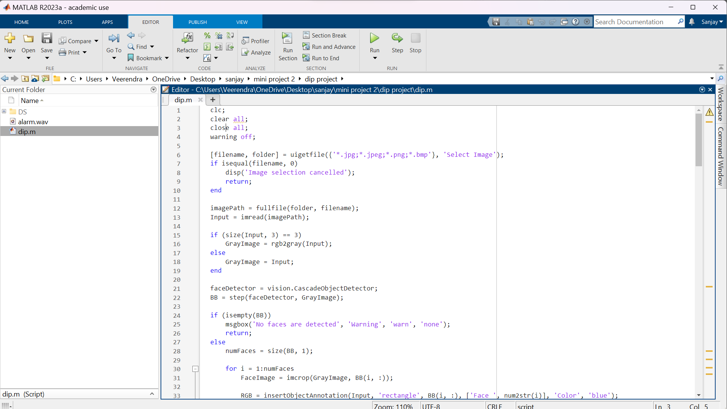

Fig 5.1:Driver Drowsiness Detection Codes

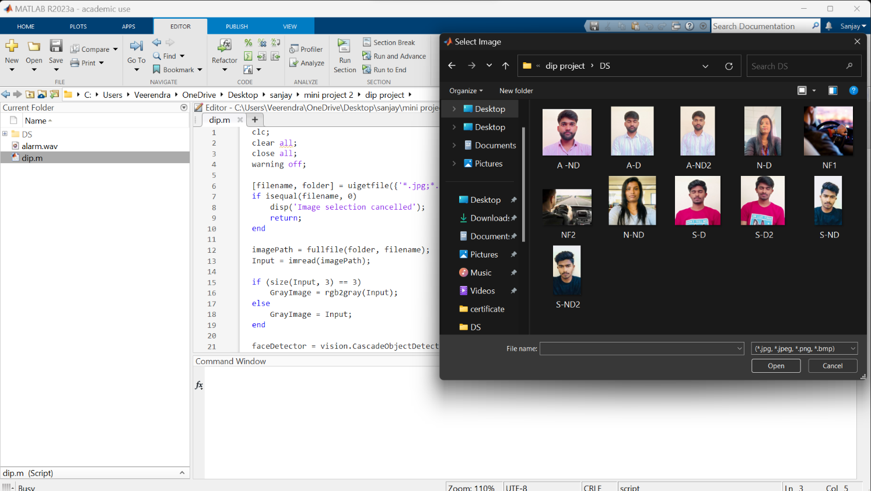

Fig 5.2:selection of image from dataset

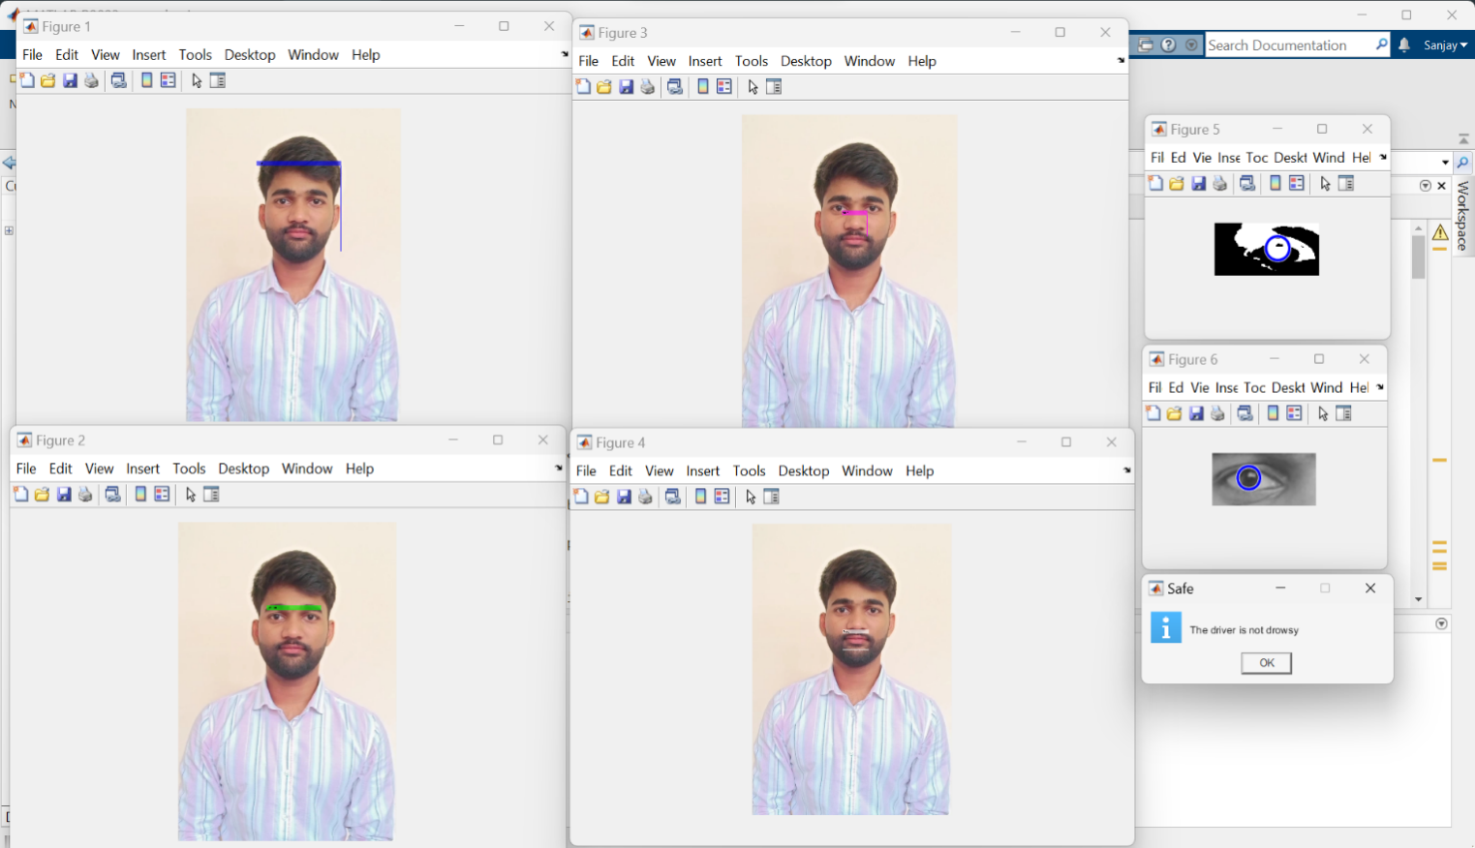

Fig 5.3:The driver is not Drowsy

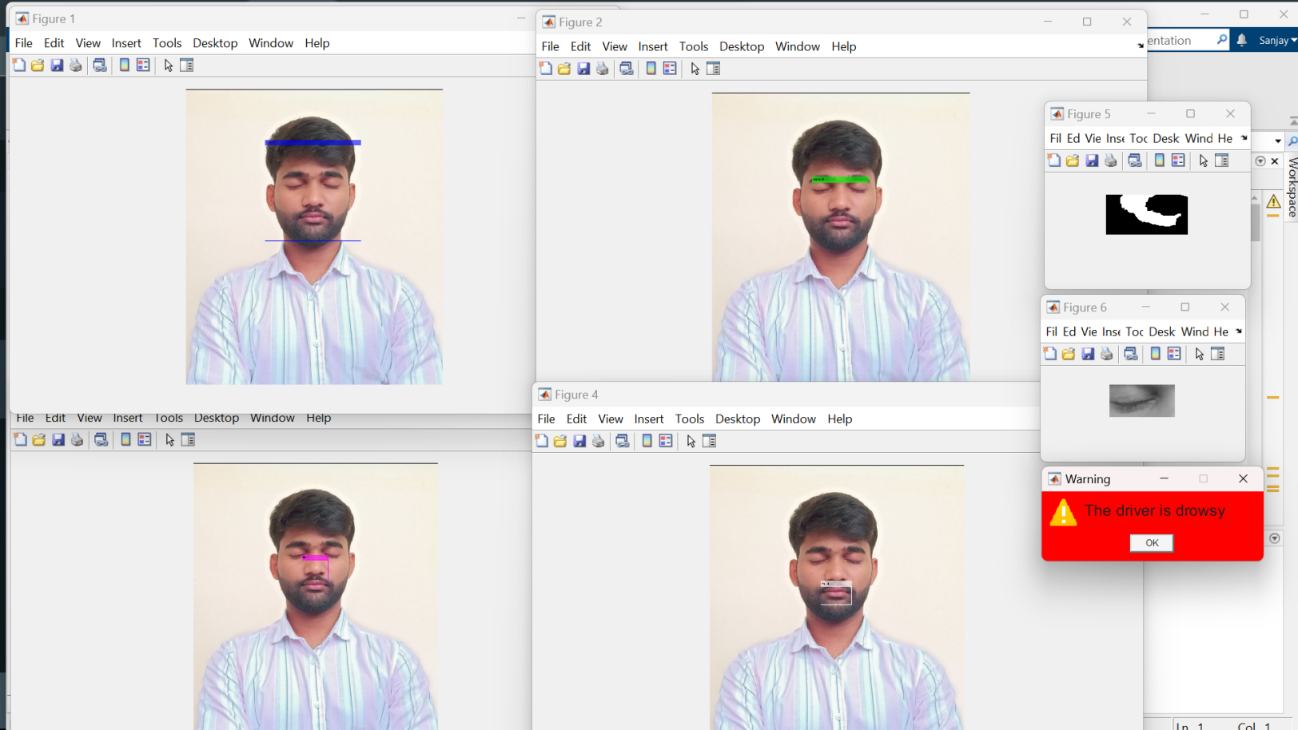

Fig 5.4:The driver is Drowsy

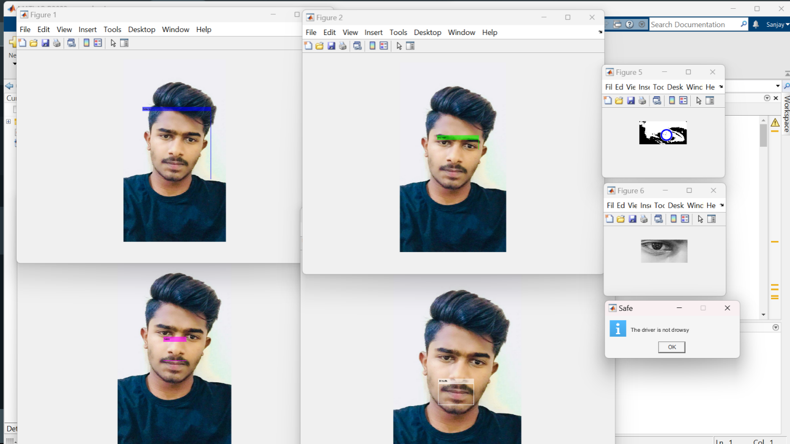

Fig 5.5:The driver is not Drowsy

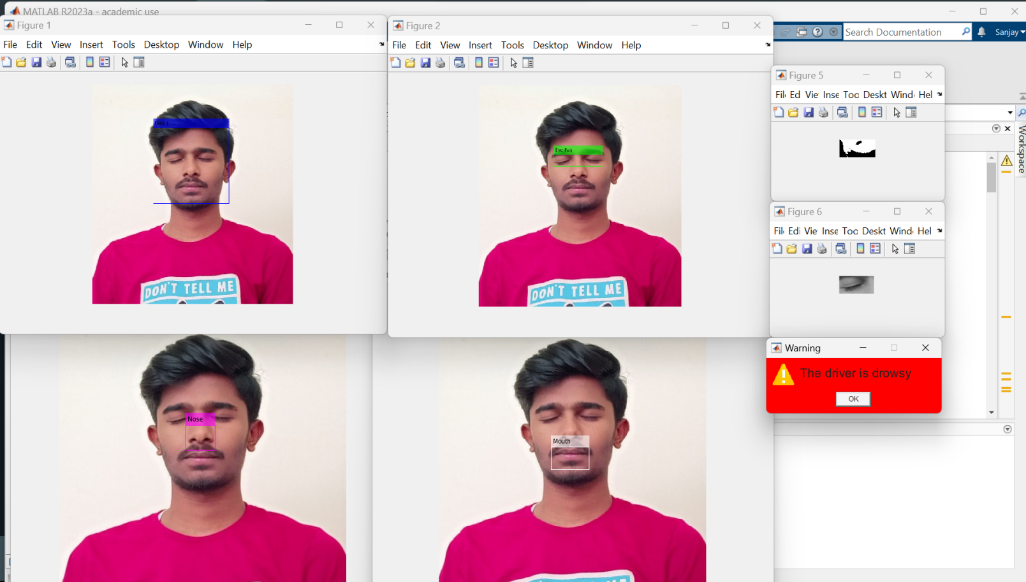

Fig 5.6:The driver is Drowsy

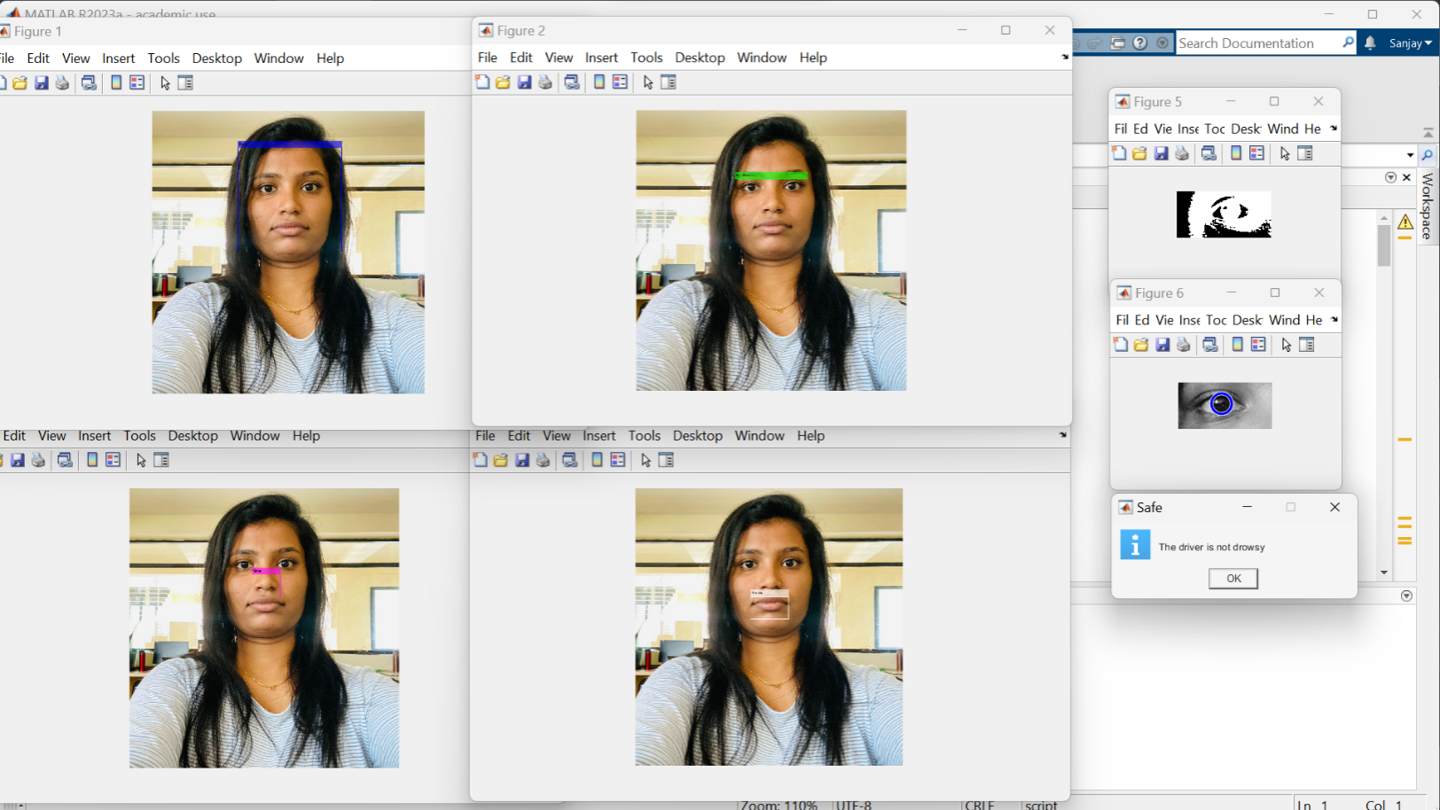

Fig 5.7:The driver is not Drowsy

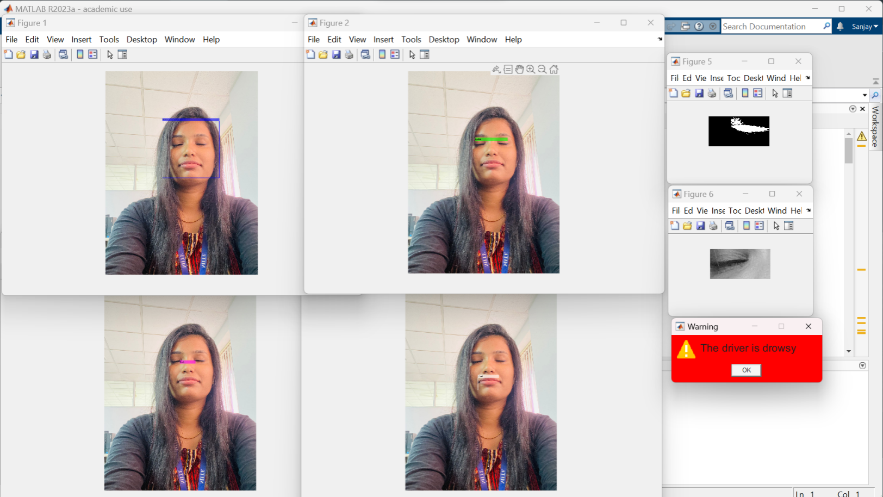

Fig 5.8:The driver is Drowsy

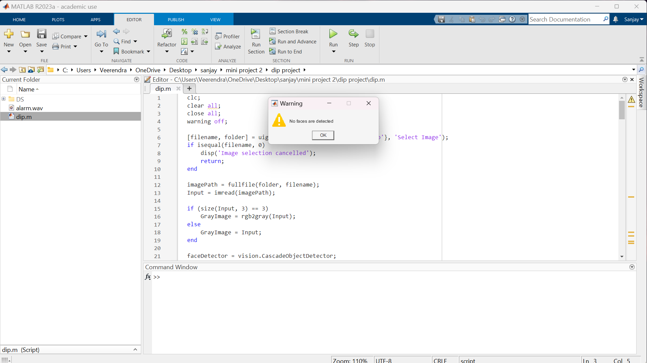

Fig 5.9:No faces are Detected

Chapter 6

FUTURE ENHANCEMENTS

1. Real-Time Monitoring: Improve the system's efficiency to enable real-time monitoring of the driver's drowsiness levels during actual driving scenarios.
2. Multi-modal Sensing: Incorporate additional sensors like infrared cameras or wearable devices to capture physiological indicators such as heart rate and head movements, enhancing the accuracy of drowsiness detection.
3. Machine Learning Techniques: Integrate machine learning algorithms to enable the system to learn and adapt to individual driver behavior patterns, leading to personalized and more accurate drowsiness detection.
4. Driver Profiling: Develop a mechanism to track and analyze long-term driver behavior patterns, establishing personalized baselines for each driver and providing more precise drowsiness alerts.
5. Integration with Advanced Driver Assistance Systems (ADAS): Integrate the drowsiness detection system with ADAS to provide comprehensive driver safety solutions, such as adaptive cruise control and lane departure warnings.
6. Robustness and Environmental Adaptation: Enhance the system's performance in varying lighting conditions, driver appearance changes, and other environmental factors through techniques like dynamic thresholding and lighting compensation.
7. Data Logging and Analysis: Implement data logging to collect and analyze driver drowsiness data over time, identifying patterns and risk factors associated with drowsiness for research and intervention strategies.

CONCLUSION

In conclusion, the Driver Drowsiness Detection project successfully demonstrated the effectiveness of using fuzzy logic and computer vision techniques to detect driver drowsiness based on eye behavior. By analyzing captured images or video frames, the system detected faces, tracked eye movements, and provided timely alerts when signs of drowsiness were detected. The project showcased the potential of technology in enhancing driver safety by mitigating the risks associated with drowsy driving. With further advancements and integration of machine learning and real-time monitoring, this system holds promise for wider implementation in vehicles, contributing to a safer and more vigilant driving experience.

Chapter 7

REFERENCES

* Tutorialspoint - Digital Image Processing

Website: <https://www.tutorialspoint.com/dip/index.htm>

* MATLAB Image Processing Tutorial:

Website: <https://www.mathworks.com/products/image.html>

* Teachers
* Internet and other resources
* OpenAI(CHATGPT)